**Lab 3 Code:**

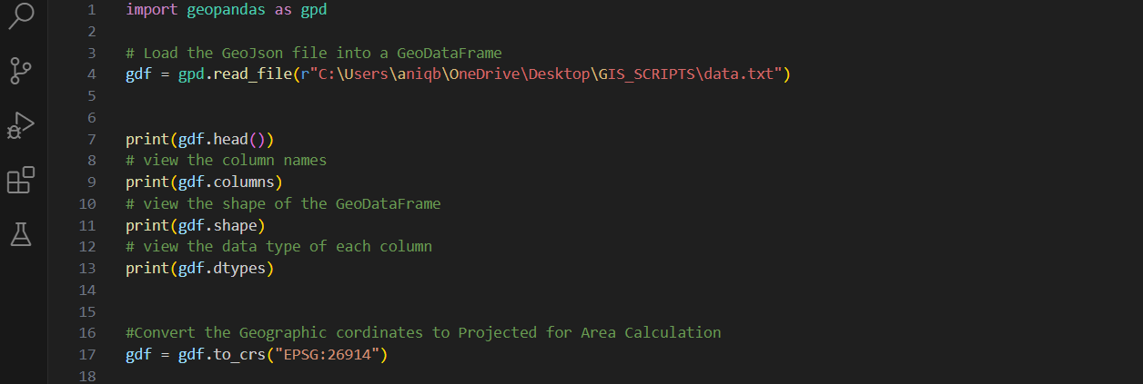

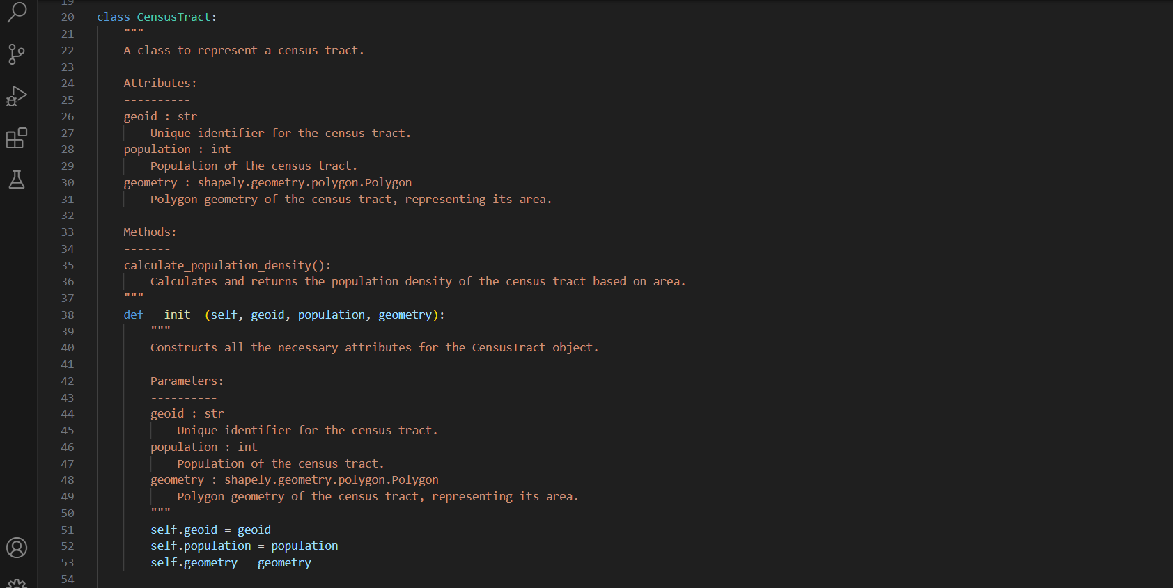

**Results:**

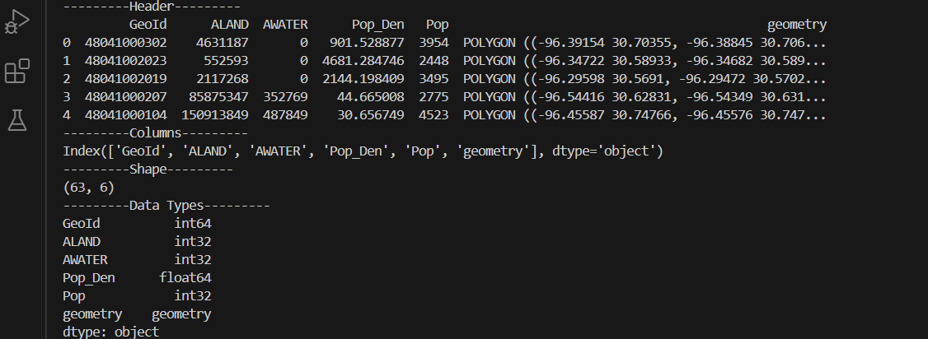

Final Geo-Data frame header after calculating and adding Population Density Column.

